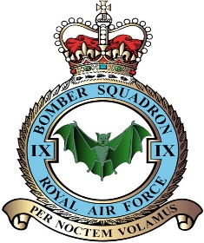
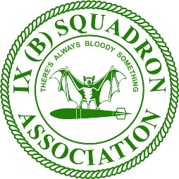
PRESIDENT: Air Marshal (R’td) Stu Evans CBE RAF CHAIRMAN: Gp Capt Ian Sharrocks OBE RAF SECRETARY: WO (R’td) Dean Wood RAF TREASURER: Mr & Mrs Mike & Eve Pritchard ASSISTANT SECRETARY: Chf Tech Rob Swanson RAF
Web site: www.9sqn.co.uk
Email: association.sec@9sqn.co.uk

8 Oct 21
BARDNEY REMEMBRANCE SERVICE 2021

Dear Member,

As we continue to emerge from the grip of COVID restrictions I am pleased to confirm that we are able to hold our traditional Barney Village Remembrance Service on the 14th November this year.

The Village Methodist Hall at the top of Church Lane will be open from 0900 for teas/coffees and the church service will start promptly at 1000. The Association Standard will be laid on the altar by the Association Standard Bearer during the first hymn. During the last hymn, he will retrieve the Standard and lead the procession from the church, down the hill to the village green. The Association Standard Bearer will position to the side of the IX(B) Sqn Memorial on the village green. The rest of the congregation will proceed to the village memorial, where a short service will be held. The village Roll of Honour will be read, followed by The Exhortation.

At the end of the village events, the Vicar will make it clear to the IX(B) Association group that it is our turn our lay wreaths at the IX(B) Sqn Memorial. Wreaths will be laid by the Association Committee. Finally, the Association Standard will be marched off down the ramp, along the main road, past the village memorial, then up Church Lane, where it will be cased and secured.

For those still serving, you are encouraged to wear Number 1 uniform with medals, gloves, and a poppy in the right buttonhole. As a reminder, officers in uniform should salute on the first note of the Last Post, return on the last note and then remain at attention throughout the two-minute silence and during the Reveille. Other ranks and all those in civilian clothes are not to salute but are to come to attention on the first note of the Last Post until the last note of the Reveille.

Following the Remembrance Service, the Bardney Heritage Centre has again kindly offered to make lunch available from 1200 for those would be interested. The cost will be £15 per person for a two-course carvery lunch with tea and coffee. If you would wish to take lunch, please complete the form below and respond to me via email at association.chairman@9sqn.co.uk.

Please can I ask for all responses no later than Friday 5th Nov. If you have any questions, please do not hesitate to get in contact and I hope to see you on the 14th.

Yours Aye,
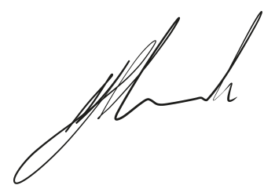

2021 REMEMBRANCE SUNDAY – BARDNEY

FROM…………………………………… …….…ASSN NO……….…….

p I/we wish to attend the 2021 Bardney Remembrance Sunday Service and Lunch. Total number of attendees……….
p I enclose a cheque for £…………………..for the Remembrance Sunday Lunch. Or
p I have paid £……………..……by BACS/internet home banking transfer to - Bank of Scotland, Sort Code: 12-11-03, Account No: 00403116. Please use your name as the reference.

Member’s Signature…………………………………………………Date………..……………………..

1 Please indicate if you have any special dietary requirements.
2 Please make cheques payable to ‘The IX(B) Squadron Association’ and send them to:

The IX(B) Sqn Association Secretary
Queensmead
Mill Road
West Walton
Wisbech
PE14 7EU

