25 Sep 17

MINUTES OF IX (B) SQN ASSOCIATION ANNUAL GENERAL MEETING HELD ON 23 Sep 17 AT RAF MARHAM

Present | R Ashton, M Ashton,R Blackburn, Y Blackburn, S Bowers, S Bowers, A Bridges, C Carr, I Carr, G Cunningham, V Cunningham, S Evans (President), J Feneley, A Ferguson (Vice President), L Ferguson, J Fox, G Gilby, B Goodwin, A Hargreaves, N Hay (Chairman), C Hay, J Higgins, C Howard, T Howatt, M Howatt, M Inder, R James (Historian), E Kelly, P Lenihan (Treasurer and Sec), J Lenihan, E Lyon, S Milligan, R Paine, C Phipps, M Pritchard, E Pritchard, H Reid, J Shephard, M Shephard, R Swanson (Dep Sec), M Thomlinson, D Wilson, D Wood
Apologies | A Holland, S Peach, A Turk.
Item 1 - Welcome  The Chairman opened the Meeting and welcomed 43 members to the IX(B) Sqn Assn Reunion, and to RAF Marham.  Item 2 –  - Minutes of the Last Meeting. The Chairman noted that the minutes of the previous AGM had been posted on the Assn’s website for the previous 10 months. He requested that the meeting ratified those minutes as a true and accurate record.  Proposer: A Ferguson  Seconder: R Blackburn  - Matters arising from the previous meeting. The Chair and asked that that the meeting approved that there were no matters arising from the previous meeting.  Proposer: A Ferguson  Seconder R Blackburn  Item 3 – Financial Reports.  - The treasurer presented the Financial Statement for the FY 16/17. It is presented in full at Annex A. In sum: This Financial Year (2016/17) saw the Association’s holdings increase to £33995.04, which included a 9% increase in the level of subscriptions. Income was £32,119.07; a 17% increase over the previous year that resulted in a surplus of £4891.34 and this is the first year the Charity has benefitted from Gift Aid. Expenditure on charitable activities was £7,730.90 in year. The treasurer concluded that this FY saw a healthy balance being brought forward into the FY 17/18 and whilst several accounting observations had been made during an independent financial assessment, he was content that these accounts were a true and accurate representation on the FY 16/17. He requested that the members approved these accounts for publication with the Charity Commission.  Proposer: S Milligan  Seconder: E Kelly  Action:  The Treasurer to lodge the Accounts for the 16/17 FY with the Charity Commission  - The treasurer presented the FP for Fy18/19. It is presented in full at Annex B. The treasurer requested the meeting’s thoughts on allocating £600 to conduct a recce for a combined Junior Sqn and IX (B) Sqn commemorative visit to Tromso for the 75th Anniversary of the Tirpitz raid. The meeting approved the application. In sum, he stated that the committee’s intent is to look to increase core income by 15% through increasing gift aid and the correct subscription levels. He stated that the Charity was in good health and that there was sufficient restricted and unrestricted funds available to deliver the Charities stated aims for the year and requested that the meeting approved the FP 2018/19.  Proposer: R James  Seconder: C Carr  Action:  The Treasurer to conduct a recce at Tromos 12/13 Nov 2017 and report his findings to the committee and members.  Item 4 – Re-Election of Trustees  The meeting had to approve the re-election, or seek election of any new trustees for the forthcoming FY. There were no new nominations for trustees and it was proposed that the current board is re-elected.  Proposer: R James  Seconder: C Carr  Item 5. – Reunion Event 2017  The Chairman presented to the members the running order and contact numbers for the days reunion event.  Item 6. – Remembrance Sunday.  The Vice President reported that the planning for the Remembrance Sunday at Bardney was progressing well. He reiterated the support given to it by the local populace and informed the meeting that there were places for 35 pers. Costs were £15 per head with costs for the Standard Party being met by the Assn.  Item 7 – Cenotaph March  The Historian informed the meeting that all 20 places on this year’s event had been allocated: there were 2 reserves. He informed the meeting that Harry Irons would be picked up by Black Cab and that the transport and marching arrangements were understood by all participants. He invited members to apply for the event 2018.  Item 8 – Arboretum Memorial  The members were informed that building and placement of the memorial was on track for the dedication ceremony 13 Oct. 120 pers were attending the event with tea and coffee being provided prior to and after the event. Those attending had been sent their joining instructions. The Chair thanked the Historian and John Fox (the memorial designer) for all of their hard work.  Item 9 – AOB  It was noted that RAF Marham now has the facility to place memorial plaques to its fallen. It was agreed that the Assn would seek to place plaques within this new facility.  Action: The Dep Sec was to confirm with the Chair the number, names and dedications and then commission plaques to be placed on the memorial wall at Marham.  The meeting was informed of the costs of commissioning an Assn Standard. It was agreed that Mr Inder was to continue with these investigations and to present full costings to the Chair and committee to approve funding.  Action: The Sqn WO was to finalise full costs for and Assn Standard andwas to present these to the Chair for funding approval.  The meeting was informed that those who had email addresses would receive TABS electronically. Those who wished hard copy were to confirm with the Assn Sec.  Item 8 – Date for next meeting  13. The date for the reunion 2018 is yet to be confirmed. It will ensure that all Sqn members would be available post det/POTL. The Secretary will announce the date through TABS, Social Media and correspondence. |  | Treasurer  Treasurer  Dep Sec  Sqn WO  All members  Sec

PJ Lenihan
Minion to the Sec

Annexes:

- Financial Report 2016/17
- Finacial Plan 2018/19.
ANNEX A TO
IX Sqn Assn AGM
Dated 25 Sep 17

Report on the FY 2016/17 for the AGM of the IX (B) Squadron Association held at RAF Marham on 23 September 2017 at 1100 hours

Sirs, Ladies gentlemen. I make no apologies for the dryness of the treasurer’s report – I am afraid there is a certain format we must follow in order to comply with the Charity Commission’s directives. I have been asked by several members why do you do all this “boring stuff and send it to us?” It is as a consequence of the high turnover on our account and also that our income is in excess of £10K per annum; therefore we have to jump through all of these hoops in order to qualify for gift aid and other benefits of being a charity. So please bear with me whilst I present you with the boring stuff.

Now, this has been posted on the web site for the last 14 days and I do hope that you have read through the 2016/2017 annual report to the Charity Commission. The purpose of this bit of my report to you is for you challenge any bits you are unhappy with: so, as I report to you, please do stop me and “buy one” and I will hopefully be able to clear up any questions you may have. At the end of this presentation, I will ask for a proposer and seconder that attests that these records represent a true and accurate record of our activities last year. Once you approve these accounts, I can then send them off to the Charity Commission.

These accounts reflect the work of your committee over the previous year and, to this end we have to demonstrate to the Charity Commission that we have continued to meet the aims and objectives of our Charity to whit:

We have to demonstrate our Impact and achievements for the public benefit:

• To promote the efficiency of the RAF by preserving its traditions and esprit-de-corps

o The Charity has now completed its major two-year fundraising initiative to purchase a memorial to its fallen members; this to be placed at the National Arboretum. The Association delivered a formal dinner at the RAF Museum at Hendon and the Association marched past the Cenotaph during the National Service of Remembrance ceremony in London.

• To maintain contact with past members of the Squadron.

o The Charity has a current membership list of over 450 members: a 10% increase over the previous FY. These comprise active and retired members of the Squadron, their spouses and supporters. It also contains members who have no service background, but have become members through the camaraderie displayed by the Association. Of this membership, there are 196 wholly active members, again reflecting a 10% increase in activity, with the remainder semi or intermittently active within the Association.

o The Association also publishes an annual booklet that highlights Association and Squadron events. This is distributed to all Association members and is made available to the general public.
• To educate and inform the general public about the work of RAF Bomber Command, Strike Command, Air Command and their subordinate formations,

o The Association continues to fund and promote its web site. Listed here are all Association meeting notices, history and research posts. It contains archives of historical and current aircraft and posts articles from historians, Association and Squadron members.

• To make grants to, and supporting charities, projects or appeals associated with the above commands.

o The Association made a grant of £100 in support of Air Command in providing transport for serving airmen to attend the funeral of Jack Linaker – a Lancaster veteran.

Now the really dry bit:

This Financial Year (2016/17) sees the Association’s holdings increase to £33995.04, which represents the culmination of two years fundraising for funds for the Memorial at the National Arboretum. It is particularly pleasing to see a 9% increase in the level of subscriptions to £1990; this reflecting members changing their subscriptions to the correct level.

Income was £32,119.07; a 17% increase over the previous year that resulted in a surplus of £4891.34. This is the first year the Charity has benefitted from Gift Aid; it is noted by the Trustees that this very high return reflects the high number of previous donations for the memorial and that future year’s HMRC income will not be as high.

Expenditure on charitable activities was £7,730.90 in year, including allocated support costs and represents a 1% drop on last year. Of this, £2,285.35 supplemented costs for the Association dinner. The Bardney Remembrance Day lunch was a cost neutral event this FY.

Reserves

The treasurer, on behalf of the Board of Trustees, monitors the level of unrestricted and restricted reserves in the general fund: this based on the expected charity expenditure to provide:

• Sufficient funds to deliver the Association’s annual dinner and memorial service.

• Restricted funds to provide for a memorial at the National Arboretum.

• Restricted funds to provide maintenance costs for the memorial at the National Arboretum

• To allow the Charity to meet its objectives.

• To ensure the General funds are allocated to meet the Charity’s Aims and Objectives.

Unrestricted reserves have decreased slightly to £7,078.70, however, restricted reserves are up to a total of £26, 916.34. £26,416.34 is reserved for the memorial and £500 for in year maintenance costs. The full cost of the memorial, and its maintenance, has still to be confirmed. (please remember, this report represents the previous year – these costs are now fully understood and will be covered later) The total raised for the memorial is in excess of that set by the trustees (£20,000) and it is intended to restrict all of the memorial funds until a full financial plan is agreed. It is not anticipated that the final cost will be in excess of the total raised; hence, the balance of memorial funds, less that restricted for maintenance, can be released back to the unrestricted reserves. To that end, the unrestricted reserves meet the minimum required to deliver next year’s activities.

Plans for the future

In addition to continuing the much-valued existing activities, particularly in providing information and support for Association members, their families and the public, the Association seeks to increase its baseline in year income by 15% (traditionally £6500). There will be a large reduction in income for FY17/18 due to the absence of fundraising activities and thus baseline income levels need to increase in order to provide funds for core activities and for maintenance for the memorial.
Independent External Assessment

This was the good news, I have to report on the independent assessor’s comments that is included in this financial statement.

The independent assessor noted that this accounting period saw a reduction in the level of financial reporting and governance. Focus was placed on income generation at the beginning of the FY, with an associated drop in governance and accounting standards. Early financial activity saw income collected and managed by four sources with no overall control being exercised. Nevertheless, there is clear evidence that during the final quarter, the Association has taken remedial steps (through a series of email trails that confirm previous income and expenditure trails) that reinforces the accuracy of the accounts as presented.

The accounting software used by the association is clearly not fit for purpose and the Treasurer struggled to deliver clear accounting on a quarterly basis – his efforts no doubt hampered by income being held and managed by four differing people with each showing differing appreciation of the accounting standards required by the Association. The treasurer has demonstrated that a new accounting spreadsheet has been developed with new operating procedures to underpin its population. Additionally, it is noted that money-handling procedures has been reviewed and revised by the treasurer. This spreadsheet is deemed appropriate for the level of financial activity demonstrated by the Charity.

The Association failed to deliver evidence of quarterly financial meetings. Whilst capital expenditure was tracked and authorised via a quantifiable e-mail trail that provided financial authorisation, recording and reconciliation, cash handling procedures reverted to the standard seen at the first assessment and there was one clear example of cash being received, not independently verified, and used for payment of services delivered. Retrospective emails demonstrated reconciliation; however, these emails were not supported by receipts.

It is clear that the treasurer is well aware of the drop in accounting standards and he has demonstrated that steps have already been implemented to ensure that the Association returns to its previously delivered best accounting practices. However, the board has yet to deliver a full financial plan against which to gauge its financial targets (more of this to come!): this is a failing highlighted in the previous two accounting reviews. Furthermore, the external assessor notes that there is no clear financial plan that underpins the new financial liabilities undertaken by the Charity. A short and long-term financial plan must be delivered by the trustees from which future financial fidelity can be demonstrated (again, standby your beds – more to come).

It is noted that the following years’ financial income will reduce to the Charity’s historical norms and, as such, the Charity anticipated that it would drop below the required threshold at which an independent financial assessment is required. However, due to the inaccuracies and the breakdown in financial governance seen during the first 3 quarters of this reporting period, it is recommended that this Charity presents its accounts for independent external assessment for FY 17/18. To that end, the assessor recommends that the board ensures that:

• A budget is prepared for FY 17/18. (Outstanding recommendation from the previous FYs).
• The Charity returns to its previous practice of quarterly financial reviews.
• The Charity reviews and implements cash handling practices.
• Receipts are presented for all cash transactions.

(All of these issues were addressed in Q1 of this financial year and I can assure you we will not receive such a report from the assessor for this FY)

The assessor is therefore content that the accounts as presented are an accurate record of the 2016/17 FY but recommends that the Charity presents its accounts for independent external assessment regardless of income generated in the following FY.

I therefore seek a proposer that this report and statement of for the FY 2016/17 represents a true and accurate state of the Association’s accounts. And now a seconder?

Thank you
ANNEX B TO
IX Sqn Assn AGM
Dated 25 Sep 17

Report on the FY 2018/19 for the AGM of the IX (B) Squadron Association held at RAF Marham on 23 September 2017 at 1100 hours

And now for the financial plan for 2018/2019 – now, before those who are still awake ask – what about the FP for 2017/18, the board decided that for this FY only, and in order to immediately address the concerns of the independent assessor, that trustees would put together a FP for this year and then seek approval for the FY 2018/19. The plan which has also been published on the web, is the basis for that we are using this year. I do not wish to labour this, but before I ask you to ratify next year’s plan, I thought I would give a very quick update on where we are today:

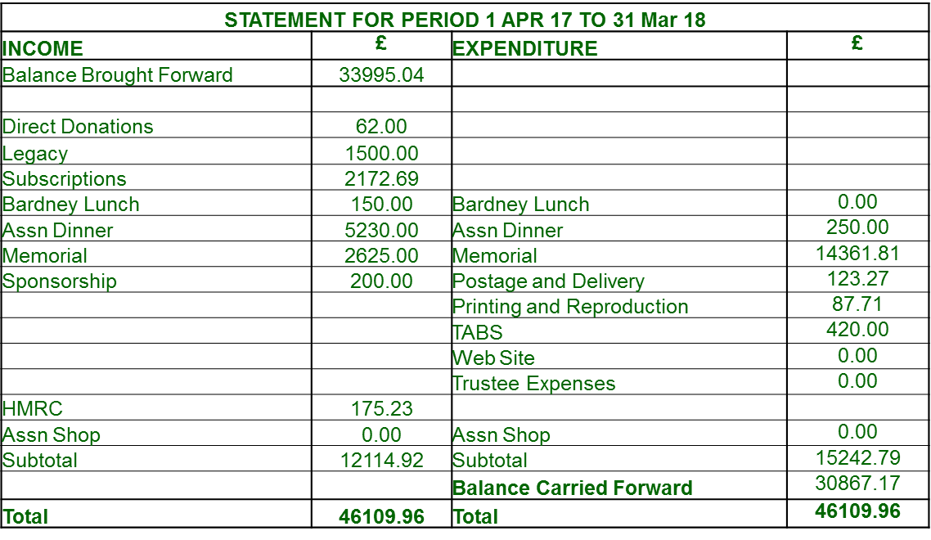

Talk very quickly on income; highlight subs increase again, increase in dinner income apropos cost and Gift aid – 25 attendees at dinner have yet to fill in GA form.

Expenses – do not anticipate any further in year costs for the memorial. Inform that no trustee expenses were claimed for the last 2 years, but still budgeted for in case of unforeseen trips.

Now, moving to FY 18/19 plan:

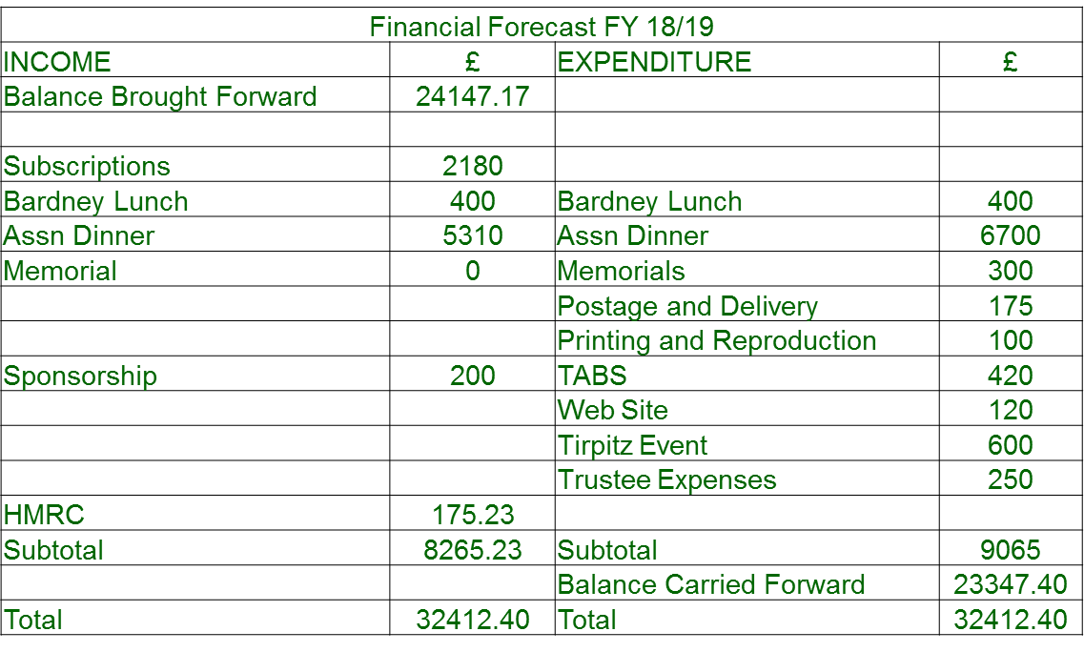Figs are slightly different to those published on the web site as more has come out of memorial fund than anticipated thus balance brought forward is different – and also includes an estimate of costs to reunion dinner 2017.

Income: Highlight again, very low HMRC income. Discuss anticipated refund in import duties for memorial, anticipated to be in the region of £1800

Expenses: Cost of upkeep for memorials. Introduce Tirpitz event (check with Nick if want to talk about it here or in AOB).

If content, I would seek a proposer that the committee adopts the FP 2018/19. Seconded?

